TPO’S MESSAGE
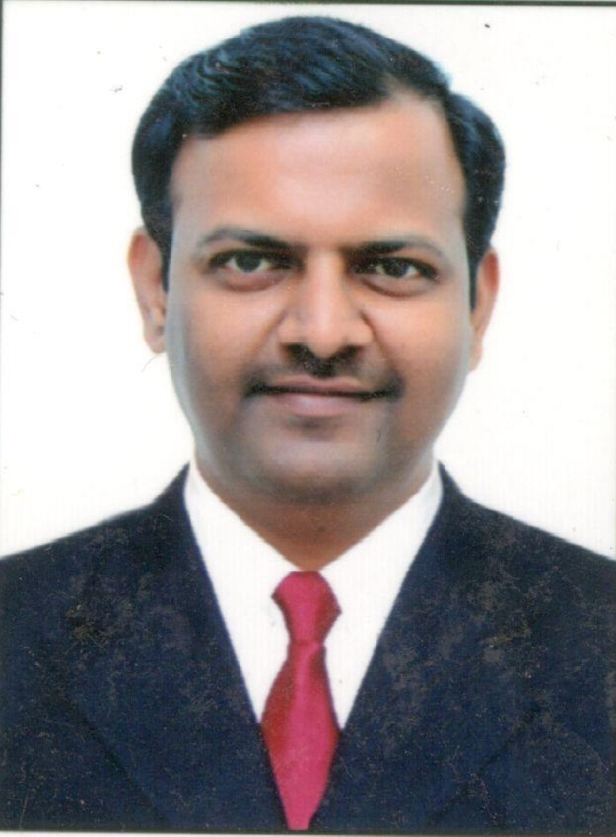
Mr. Shyam. S. Awate, TPO,IVM’s KBIPER.
email ID:placement.iiper@gmail.com
“If we train the students right, they will be placed right.”
The training and placement cell is the most vibrant department of our college. We want our students to be able to choose a career according to their choice and train them to achieve their respective career goals to be a responsible pharmacist, as well as a citizen of India.
These are the various activities which we do for achieving our final goal:
- Regular training of students for developing their personalities and skills which will make them ready for their suitable job/business by arranging sessions of various industry experts.
- Also we keep guest lectures of Industry officials to guide regarding various opportunities and current advancements in the pharma sector.
- We conduct KASH / SWOT analysis.
- We conduct Mock Interviews of T.Y and Final year students and categorize them into Job Seekers & Job Creators,according to their personality, family background and liking and groom them accordingly.
- We have tie ups with various industries where our students get hands-on training for one month and also they are placed there if the company finds their skills suitable for the given job position.

